May 15, 2024

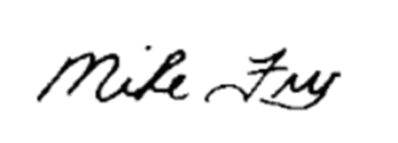

Excel Advantage Services, LLC

3824 Cedar Springs Rd #801-2245

Dallas, TX 75219

RE: Childress County and Excel Advantage Services, LLC Tax Abatement Agreement Amendment

Please review the following changes on the amendment attached:

* + **Section 2/B:** Commercial Operations Date – Updated
  + **Section 3/A:** Size of Project - Updated
  + **Section 3/A:** Removed last sentence
  + **Section 3/C:** Construction and Commercial Operations Dates – Updated
  + **Section 3/F:** Commercial Operations Date – Updated

If you have any questions, please do not hesitate to contact us. Thank you!

Sincerely,

Mike Fry

Senior Director – Energy Services

mfry@keatax.com

**Amended and Restated Tax Abatement Agreement by and between Childress County, Texas and Excel Advantage Services, LLC**

# State of Texas

County of Childress

This Amended and Restated Tax Abatement Agreement (the "**Agreement**") is made and entered into by and between Childress County, Texas (the "**County**"), acting through its duly elected officers, and Excel Advantage Services, LLC, doing business as "Misae Solar Park II," owner of Eligible Property (as hereinafter defined) to be located on a tract of land within Childress Reinvestment Zone 2017-01, more specifically described in Attachment A to this Agreement. This Agreement repeals, replaces, amends, and restates that certain Tax Abatement Agreement between the parties executed on or about August 13, 2018 (the "**Original Agreement**"). This Agreement becomes effective upon final signature by both parties. The Agreement remains in effect until fulfillment of the obligations described herein, unless terminated earlier as provided herein.

# **I. Authorization**

This Agreement is authorized and governed by Chapter 312 of the Texas Tax Code, as amended, and by the Childress County Tax Abatement Guidelines and Criteria. Notwithstanding any term or provision herein to the contrary, this Agreement is intended to and shall fully comply with Chapter 312 of the Texas Tax Code and in no event can the Abatement period exceed 10 years.

# **II. Definitions**

As used in this Agreement, the following terms shall have the meaning set forth below:

1. "Abatement" means the full or partial exemption from ad valorem taxes on property in a Reinvestment Zone as provided herein.
2. "Battery Facility" means Eligible Property meeting the definition for improvements provided by Chapter 1 of the Texas Tax Code and includes, but is not limited to, a battery storage component with unknown storage capacity for the purpose of storing electricity generated, in whole or in part, on the Site, and which enters into commercial operations (i.e., COD) on or prior to December 31, 2025. For purposes of clarity, any battery storage component that does not attain COD on or prior to December 31, 2025, shall be excluded from the meaning of "Battery Facility" hereunder.
3. "Calendar Year" means each year beginning on January 1 and ending on December 31.
4. "Certificate" means a letter, provided by the Owner to the County, certifying that Owner has completed construction of the solar power project described herein ("Project") and the Battery Facility, if any, outlining the Improvements and stipulating the overall Nameplate Capacity (designated in MW AC) of the Project. Upon receipt of the Certificate, the County may inspect the Site in accordance with this Agreement to determine that the Improvements are in place as certified.
5. "Certified Appraised Value," means the appraised value, for property tax purposes, of the property within Childress Reinvestment Zone 2017-01 as certified by the Childress County Appraisal District for each taxable year.
6. "Eligible Property" means property eligible for Abatement under the Childress County Tax Abatement Guidelines and Criteria, including: new, expanded or modernized buildings and structures; fixed machinery and equipment; a Battery Facility; Site improvements; related fixed improvements; other tangible items necessary to the operation and administration of the project or facility; and all other real and tangible personal property permitted by Chapter 312 of the Texas Tax Code and the Childress County Tax Abatement Guidelines and Criteria. Taxes on Real Property may be abated only to the extent the property's value for a given year exceeds its value for the year in which the Agreement is executed. Tangible personal property located on the Real Property at any time before the date the Agreement is signed is not eligible for Abatement. Tangible personal property eligible for Abatement shall not include inventory or supplies.
7. "Improvements" means Eligible Property meeting the definition for improvements provided by Chapter 1 of the Texas Tax Code and includes, but is not limited to, any building, structure, or fixture erected on or affixed to the land. Improvements specifically include the Owner's substation and switching station that will be located in Childress County.
8. "Owner" means Excel Advantage Services, LLC, the entity that owns or leases the Real Property for which the Abatement is being granted, and any permitted assignee or successor in interest of Excel Advantage Services, LLC. The term "Excel Advantage Services, LLC" means and includes Owner. An "Affiliate" of an Owner means any entity that directly or indirectly through one or more intermediaries, controls or is controlled by or is under common control with such Owner. For purposes of this definition, "control" of an entity means (i) the ownership, directly or indirectly, of fifty percent (50%) or more of the voting rights in a company or other legal entity or (ii) the right to direct the management or operation of such entity whether by ownership (directly or indirectly) of securities, by contract or otherwise.
9. "Real Property" means Eligible Property meeting the description for real property provided by Chapter 1 of the Texas Tax Code.
10. "Reinvestment Zone" means the Childress Reinvestment Zone 2017-01, the reinvestment zone (as that term is defined in Chapter 312 of the Texas Tax Code) created by Childress County and described in Attachment A to this Agreement.
11. "Site" means the portion within the Reinvestment Zone on which Owner makes the Improvements for which the Abatement is granted hereunder, and which is shown on Attachment C.
12. "Nameplate Capacity" means the generating capacity of the Project to be constructed as measured by the total inverter sizing and, where appropriate, may refer to the total or overall generating capacity (AC).
13. "Lender" means any entity or person providing, directly or indirectly, including an assignee of an initial Lender, with respect to the Improvements or Project any of (a) senior or subordinated construction, interim or long-term debt financing or refinancing, whether that financing or refinancing takes the form of private debt, public debt, or any other form of debt (including debt financing or refinancing), (b) a leasing transaction, including a sale leaseback, inverted lease, or leveraged leasing structure, (c) tax equity financing, (d) any interest rate protection agreements to hedge any of the foregoing obligations, and/or (e) any energy hedge provider. There may be more than one Lender. Owner, at its election, may send written notice to the County with the name and notice information for any Lender.

# **III. Improvements in Reinvestment Zone**

Owner anticipates making the following Improvements:

1. Owner anticipates constructing the Improvements on the Site consisting of a solar power facility with approximately three hundred twenty (320) megawatts (AC) of Nameplate Capacity located in the Reinvestment Zone. Owner is contemplating constructing a Battery Facility on the Site in the Reinvestment Zone. The Certified Appraised Value of the Improvements and Battery Facility, if any, will depend upon annual appraisals by the Childress County Appraisal District.
2. Improvements also shall include any other property in the Reinvestment Zone owned or leased by Owner and meeting the definition of "Eligible Property" that is used to produce solar power and perform other functions related to the production, storage, distribution, and transmission of electric power, including, without limitation, solar panels, transmission lines, substations, batteries, and other related materials and equipment.
3. Owner anticipates commencing construction of the Improvements by December 31, 2024and anticipates achieving the COD (defined below) on or before December 31, 2025. Owner further agrees that failure of COD to commence by December 31, 2025 shall constitute a material default under this Agreement unless, by no later than 6:00 p.m. (CDT) on November 30, 2025, Owner notifies the County of a delay in achieving COD (a "Notice of Delay"). In the event Owner issues such a Notice of Delay to the County, then (1) the commencement of the Abatement (as well as the table of Abatement in Paragraph IV(B)) automatically shall be postponed by one (1) year; (2) Owner shall be liable for any and all ad valorem taxes owed during the period from the Notice of Default through the commencement of the Abatement; (3) no material default (or any other default) shall be deemed to have occurred with regard to this Paragraph III(C); and (4) no other term or condition of this Agreement shall be amended, modified, or deemed waived by either Party by virtue of this Paragraph III(C), except that the deadlines for any certifications between the County and Owner shall be postponed by one year to mirror the original schedule set forth in this Agreement. Owner may exercise the Notice of Delay and related delay rights in this Paragraph III(C) three (3) times.
4. Notwithstanding anything herein to the contrary, the County hereby fully, unconditionally, and irrevocably waives and releases the Owner's obligations under Paragraph III(C) of the Original Agreement (i) to have achieved COD on or before December 31, 2020, and (ii) to have issued a Notice of Delay by no later than November 30, 2020, to have extended the deadline to achieve COD. To the extent of any default under Paragraph III(C) of the Original Agreement, the County hereby fully, unconditionally, and irrevocably waives such default.
5. Notwithstanding anything herein to the contrary, the County and Owner agree that failure by the Owner to complete a Battery Facility according to the same timeline as the Improvements in Paragraph III(C) shall not constitute a material breach of this Agreement.
6. For purposes of clarity, in the event that the Owner develops (or plans to develop) a battery storage component but the COD for such battery storage component is (or is projected to be) after December 31, 2025, then such battery storage component shall be excluded from the Eligible Property under this Agreement. Neither the immediately preceding sentence nor any other term or condition of this Agreement (nor its existence) shall operate as any constraint, limitation, or impediment to the ability of the Owner to pursue or (or also) to enter into any separate abatement agreement with respect to such battery storage component that fails (or would fail) to qualify as Eligible Property hereunder.

# **IV. Term and Portion of Tax Abatement; Taxability of Property**

1. The County and Owner specifically agree and acknowledge that the property in the Reinvestment Zone shall be taxable in the following ways before and during the Term of this Agreement:
   1. Property not eligible for Abatement, if any, shall be fully taxable at all times;
   2. The Certified Appraised Value of property existing in the Reinvestment Zone prior to execution of this Agreement shall be fully taxable at all times;
   3. Prior to commencement of the Abatement period designated in Paragraph IV(B), 100% of property taxes levied on the Certified Appraised Value of real and personal property owned by Owner and located in the Reinvestment Zone will be owed and payable by Owner;
   4. County property taxes on the Certified Appraised Value of Eligible Property shall be abated for the periods and in the amounts as provided for by Paragraph IV(B) below; and
   5. 100% of the Certified Appraised Value of Eligible Property owned by Owner and existing in the Reinvestment Zone shall be fully taxable after expiration of the Abatement period designated in Paragraph IV(B), including the remainder of the Term.
2. The County and Owner specifically agree and acknowledge that this Agreement shall provide for tax Abatement, under the conditions set forth herein, of all Childress County, Texas property taxes as follows:
   1. Beginning with the Calendar Year after the Calendar Year in which the COD occurs and ending upon the conclusion of ten (10) full Calendar Years thereafter, the Abatement percentage of value of Eligible Property to be abated each year is as follows:

|  |  |
| --- | --- |
| **Year** | **ABATEMENT**  **PERCENTAGE** |
| 1 | 80% |
| 2 | 80% |
| 3 | 80% |
| 4 | 80% |
| 5 | 80% |
| 6 | 80% |
| 7 | 80% |
| 8 | 80% |
| 9 | 80% |
| 10 | 80% |

* 1. The foregoing percentage of property taxes on the Certified Appraised Value of all Improvements and Battery Facility, if any, described in the Certificate (and actually in place in the Reinvestment Zone) are abated in the respective period designated above.
  2. The foregoing percentage of property taxes on the Certified Appraised Value of any and all otherwise taxable personal property owned by Owner and located in the Reinvestment Zone are abated in the respective period designated above.
  3. The base year (as of January 1, 2021) value for the proposed Improvements is zero.
  4. The Abatement granted under this Agreement shall commence upon January 1 of the year after the date that the Project commences commercial operations ("COD"), and shall expire at the end of the tenth (10th) year after the COD. Owner shall provide certification of the COD in writing both to the County and to the Childress County Appraisal District within sixty (60) days of completion of the Project. Notwithstanding any statement or implication in this Agreement to the contrary, the parties agree that the abatement granted hereby shall not extend beyond 10 years.

C. A portion or all of the Improvements may be eligible for complete or partial exemption from ad valorem taxes as a result of existing law or future legislation. This Agreement is not to be construed as evidence that no such exemptions shall apply to the Improvements.

D. Owner agrees that the Improvements and Battery Facility, if any, described in Paragraph III, once constructed, will remain in place until at least twenty (20) Calendar Years after the date the Certificate for such Improvements and Battery Facility, if any, is provided to Childress County by the Owner ("Term"); provided that nothing herein prevents Owner from replacing equipment or fixtures comprising the Improvements prior to that date, as long as such replacement does not result in a reduction of the Certified Appraised Value of the Improvements. In the event that Owner removes Improvements (comprising in the aggregate not more than 10% of all Improvements), the Owner's removal shall not be deemed a default under this Agreement if Owner pays to County as liquidated damages for such removal from the Abatement in this Agreement, within thirty (30) days after demand, all taxes for such removed Improvements (which otherwise would have been paid to the County through the date of such removal without benefit of a tax abatement) with interest at the statutory rate under the Texas Tax Code, as amended, but without penalty. IN THE EVENT OF A BREACH OF THIS PARAGRAPH IV(F), THE SOLE REMEDY OF THE COUNTY, AND OWNER'S SOLE LIABILITY, WILL BE FOR OWNER TO PAY TO THE COUNTY THE FULL AMOUNT OF ACTUAL TAXES ABATED AT ANY TIME UNDER THIS AGREEMENT ON THE REMOVED IMPROVEMENTS, LESS ANY TAX PAYMENTS OR PAYMENTS IN LIEU OF TAXES MADE AT ANY TIME TO THE COUNTY FOR THE REMOVED IMPROVEMENTS. IN THE EVENT OF A BREACH OF THIS PARAGRAPH IV(F), ANY TAXES DUE BY OWNER SHALL BE SUBJECT TO ANY AND ALL STATUTORY RIGHTS FOR THE PAYMENT AND COLLECTION OF TAXES IN ACCORDANCE WITH THE TEXAS TAX CODE.

# **V. Representations**

The County and Owner make the following respective representations:

1. Owner represents and agrees that (i) Owner, its successors and/or assigns, will have a taxable interest with respect to Improvements to be placed on the Site; (ii) construction of the proposed Improvements described in Paragraph III will be performed by the Owner, its successors and/or assigns and/or their contractors or subcontractors, (iii) Owner's or Owner's successors' and assigns' use of the property in the Reinvestment Zone is limited to that which is consistent with the general purpose of encouraging development or redevelopment of the area during the period of the Abatement, (iv) all representations made in this Agreement and in the Application for Abatement, if any, are true and correct in all material respects to the best of Owner's knowledge, and (v) Owner will make required filings, if any, with the Office of the Comptroller of Public Accounts and other governmental entities concerning this Agreement that may be required of Owner by the Office of the Comptroller of Public Accounts and other governmental entities in the future.
2. The County represents that (i) the Reinvestment Zone and this Agreement have been created in accordance with Chapter 312 of the Texas Tax Code and the Childress County Tax Abatement Guidelines and Criteria as both exist on the effective date of this Agreement; (ii) no interest in the Improvements or the land on which they are located is held or subleased by a member of the County Commissioners Court, (iii) that the property within the Reinvestment Zone is located within the legal boundaries of the County and (iv) the County

has made and will continue to make all required filings with the Office of the Comptroller of Public Accounts and other governmental entities concerning the Reinvestment Zone and this Agreement.

1. Owner represents and agrees that if it builds the Improvements and if the COD occurs, the

Project will (i) add at least One Million Dollars ($1,000,000.00) to the tax roll of Eligible Property, (ii) create no fewer than one (1) new, permanent, full-time jobs, (iii) lead to a positive net economic benefit to the County of at least One Million Dollars ($1,000,000.00) over the life of this Agreement, computed to include (but not limited to) new sustaining payroll and/or capital improvement, and (iv) not solely or primarily have the effect of transferring employment from one part of Childress County to another.

# **VI. Access to and Inspection of Property by County Employees**

1. Owner shall allow the County's employees access to the Improvements for the purpose of inspecting any Improvements erected to ensure that the same are conforming to the minimum specifications of this Agreement and to ensure that all terms and conditions of this Agreement are being met. All such inspections shall be made only after giving Owner seven (7) calendar days notice and shall be conducted in such a manner as to avoid any unreasonable interference with the construction and/or operation of the Improvements. All such inspections shall be made with one (1) or more representatives of Owner in accordance with all applicable safety standards.
2. Owner shall, within ninety (90) days of the beginning of each Calendar Year, certify annually to the County its compliance with this Agreement by providing written notice to the County Judge. If Owner fails to certify pursuant to the immediately preceding sentence within such ninety (90) day period, then County may make written demand to Owner for such certification of compliance; whereupon, subject to the deemed time of delivery for such notice by County pursuant to Paragraph X of this Agreement, Owner shall have fourteen (14) calendar days to submit the certification of compliance described in this Paragraph VI(B).

# **VII. Default, Remedies and Limitation of Liability**

1. No party may terminate this Agreement unless (i) such party provides written notice by certified mail, return receipt requested (a "Notice") to the other party specifying a material default in the performance of a material covenant or obligation under this Agreement and (ii) such failure is not (x) excused by the occurrence an event of Force Majeure or (y) cured by the other party within sixty (60) days after Notice thereof, or if such failure cannot be cured within a 60-day period, the other party shall have such additional time to cure such default as is reasonably necessary as long as such party has commenced remedial action to cure such failure and continued to diligently and timely pursue the completion of such remedial action. Notwithstanding the preceding portions of this paragraph, if any default arises from a violation of law resulting from a change in law, or a change in the interpretation or enforcement of law, by a governmental entity, then such default shall not give rise to the termination of this Agreement so long as the defaulting party acts in accordance with a commercially reasonable plan of action to cure such default prepared by such defaulting party and delivered to the other party. If Owner believes that any alleged termination is improper, Owner may file suit in the proper court challenging such termination. In the event of default which remains uncured after all applicable notice and cure periods, the County may pursue the remedies provided for in Paragraph VII(D) below or the preceding Paragraph IV(F), as applicable.
2. The County shall not declare a default, and no default will be deemed to have occurred, when the circumstances giving rise to such declaration are the result of "Force Majeure." For purposes of this Agreement, the term "Force Majeure" includes events not reasonably within the control of the party whose performance is sought to be excused thereby, including (but not limited to) the following causes and events (to the extent such causes and events are not reasonably within the control of the party claiming suspension): acts of God and the public enemy, strikes, lockouts or other industrial disturbances, inability to obtain material or equipment or labor, wars, blockades, insurrections, riots, epidemics, landslides, lightning, earthquakes, fires, storms, floods, high water washouts, inclement weather, arrests and restraint of rulers and people, interruptions by government or court orders, the insolvency or bankruptcy of any of Owner's banking or depositary institutions (or the failure of any of Owner's banking or depositary institutions to permit withdrawal of any of Owner's funds for any reason that is not caused by or the fault of Owner), present or future orders of any regulatory body, civil disturbances, explosions, breakage or accident to machinery or lines, freezing of lines, inability to obtain or delays in obtaining additional necessary rights-of-way or permits (provided Owner has used reasonable efforts to obtain such rights-of-way or permits), any laws, rules, orders, acts or restraint of government or governmental body or court, or the partial or entire failure of fuel supply or any other event that is beyond the reasonable control of the party claiming Force Majeure. Notwithstanding any other provision of this Agreement to the contrary, in the event a party is rendered unable, wholly or in part, by Force Majeure to carry out its obligations under this Agreement (other than any obligation to make payment of any amount when due and payable hereunder except as identified in the preceding sentence), the obligation of such party, so far as it is affected by such Force Majeure, shall be suspended during the continuance of any condition or event of Force Majeure, but for no longer period, and such condition or event shall so far as possible be remedied with all reasonable dispatch. The party prevented or hindered from performing shall give prompt (but in no event later than twenty business days after the occurrence of such event) notice and reasonably full particulars of such event to the other party and shall take all reasonable actions within its power to remove the basis for nonperformance (including securing alternative supply sources) and after doing so shall resume performance as soon as possible. The settlement of strikes or lockouts or resolution of differences with workers shall be entirely within the discretion of the affected party, and that the above requirement that any Force Majeure shall be remedied with all reasonable dispatch shall not require the settlement of strikes, lockouts or differences by acceding to the demands of the opposing party in such strike, lockout or difference when such course is inadvisable in the reasonably exercised discretion of the affected party.
3. The County shall notify Owner and any Owner Lender of which the County has notice of any default in writing in the manner prescribed herein. All contact information for purposes of a notice of default shall be provided to the County Judge. The notice shall specify the

basis for the declaration of default, and Owner shall have periods of time specified above to cure any default. Any Owner Lender of which the County has notice shall have the right to cure any defect or default, including any defect caused by an assignee or contractor of Owner, during the same cure periods provided for Owner under this Agreement.

1. As required by section 312.205 of the Texas Tax Code, if an Owner default remains uncured after all applicable notice and cure periods, the County shall be entitled to cancel the Agreement and recover the property tax revenue abated under this Agreement though the cancellation date.
2. LIMITATION OF LIABILITY: CANCELLATION OF THE AGREEMENT (RESULTING IN A FORFEITURE OF ANY RIGHT TO ABATEMENT HEREUNDER BEYOND THE CANCELLATION DATE), RECAPTURE OF PROPERTY TAXES ABATED ONLY AS PROVIDED FOR AND ONLY UNDER THE CIRCUMSTANCES DEFINED IN PARAGRAPH VII(D) OF THIS AGREEMENT, AND/OR RECOVERY OF THE AMOUNTS PROVIDED FOR IN PARAGRAPH IV(F) ONLY AS PROVIDED FOR AND ONLY UNDER THE CIRCUMSTANCES DEFINED IN PARAGRAPH IV(F), ALONG WITH ANY REASONABLY INCURRED COURT COSTS AND ATTORNEYS' FEES, SHALL BE THE COUNTY'S SOLE REMEDY, AND OWNER'S SOLE LIABILITY, IN THE EVENT OWNER FAILS TO TAKE ANY ACTION REQUIRED BY THIS AGREEMENT, INCLUDING ANY FAILURE TO PAY AMOUNTS OWED UNDER THIS AGREEMENT. OWNER AND COUNTY AGREE THAT THE LIMITATIONS CONTAINED IN THIS PARAGRAPH ARE REASONABLE AND REFLECT THE BARGAINED FOR RISK ALLOCATION AGREED TO BY THE PARTIES. IN THE EVENT OF A BREACH OF THIS AGREEMENT, ANY TAXES DUE BY OWNER SHALL BE SUBJECT TO ANY AND ALL STATUTORY RIGHTS FOR THE PAYMENT AND COLLECTION OF TAXES IN ACCORDANCE WITH THE TEXAS TAX CODE.
3. Any notice of default under this Agreement shall prominently state the following at the top of the notice:

NOTICE OF DEFAULT UNDER TAX ABATEMENT AGREEMENT

YOU ARE HEREBY NOTIFIED OF THE FOLLOWING DEFAULT UNDER YOUR TAX ABATEMENT AGREEMENT WITH THE COUNTY. FAILURE TO CURE THIS DEFAULT WITHIN SIXTY DAYS OF NOTICE OR OTHERWISE CURE THE DEFAULT WITHIN THE TIME PERIODS PROVIDED BY THE AGREEMENT SHALL RESULT IN TERMINATION OF THE TAX ABATEMENT AGREEMENT AND MAY INCLUDE RECAPTURE OF TAXES ABATED PURSUANT TO THAT AGREEMENT.

# **VIII. Compliance with State and Local Regulations**

Nothing in this Agreement shall be construed to alter or affect the obligations of Owner to comply with any order, rule, statute or regulation of the County or the State of Texas.

# **IX. Assignment of Agreement**

1. The rights and responsibilities of Owner hereunder may be assigned in their entirety to an Affiliate without County's prior consent. Owner shall provide notice to the County of any assignment to an Affiliate. Owner's assignment of the Agreement to an Affiliate shall be final only after the execution of a formal assignment document between Owner and the assignee and the delivery of notice of the execution of such assignment agreement to the County.
2. The rights and responsibilities of Owner hereunder may be assigned in their entirety to a party other than an Affiliate, but only after obtaining the County's prior written consent, which consent shall not be unreasonably withheld, conditioned, or delayed. Any assignment by Owner to a party other than an Affiliate without first obtaining the written consent of the County shall be a default under this Agreement subject to the notice provisions, cure provisions, remedies, and other terms and conditions of Article VII above. Owner shall give the County forty-five (45) days' written notice of any intended assignment to a party other than an Affiliate, and the County shall respond with its consent or refusal within thirty-five (35) days after receipt of Owner's notice of assignment. If the County responds to Owner's notice of assignment with a refusal, the parties agree to work together in good faith to resolve the County's objections to the assignment. Owner's assignment of the Agreement shall be final only after the execution of a formal assignment document between Owner and the assignee and the delivery of notice of the execution of such assignment agreement to the County. Neither Owner's notice of an intended assignment nor the County's formal consent to an intended assignment shall constitute an assignment of the Agreement, and Owner's request for a consent to assignment shall not obligate Owner to assign the Agreement.
3. No assignment under Paragraph IX(A) or IX(B) shall be allowed if (a) the County has declared a default hereunder that has not been cured within all applicable notice and cure periods, or (b) the assignee is delinquent in the payment of ad valorem taxes owed to the County or any other taxing jurisdiction in the County. Consent to a transfer or assignment requested under Paragraph IX(B) will be subject to the County approving the financial capacity of the transferee/assignee and subject to all conditions and obligations in this Agreement being assumed and guaranteed by the transferee/assignee. The County shall not unreasonably withhold consent to a transfer or an assignment under Paragraph IX(B). The transfer or assignment shall be presumed to be reasonable where the proposed transferee/assignee demonstrates to the County its financial capacity to meet the terms of this Agreement, agrees to be bound by all conditions and obligations stated herein, and is not in default under any other agreement with the County.
4. The parties agree that a transfer of all or a portion of the ownership interests (e.g., the stock or membership interests) in Owner to a third party shall not be considered an assignment under the terms of this Agreement and shall not require any consent of the County.
5. Upon any assignment and assumption under Paragraph IX(A) or IX(B) of Owner's entire interest in the Agreement, Owner shall have no further rights, duties or obligations under the Agreement. No partial assignments are permitted by Owner.
6. In addition to its rights under Paragraph IX(A) and IX(B), Owner may, without obtaining the County's consent, mortgage, pledge, or otherwise encumber its interest in this Agreement or the Project to a Lender for the purpose of financing the operations of the Project or constructing the Project or acquiring additional equipment following any initial phase of construction. Owner's encumbering its interest in this Agreement may include an assignment of Owner's rights and obligations under this Agreement for purposes of granting a security interest in this Agreement. In the event Owner takes any of the actions permitted by this subparagraph, it may provide written notice of such action to the County with such notice to include the name and notice information of the Lender. If Owner provides the name and contact information of a Lender to the County, then the County shall be required to provide a copy to such Lender of all Notices delivered to Owner at the same time that the Notice is delivered to Owner. If Owner does not provide the name and contact information of a Lender to the County in writing, then such Lender shall not have the notice rights or other rights of a Lender under this Agreement.

## **X. Notice**

All Notices, demands, or other communications of any type given shall be given in accordance with this Section. All Notices shall be in writing and delivered, by commercial delivery service to the office of the person to whom the Notice is directed (provided that that delivery is confirmed by the courier delivery service); by United States Postal Service (USPS), postage prepaid, as a registered or certified item, return receipt requested in a proper wrapper and with proper postage; by recognized overnight delivery service as evidenced by a bill of lading, or by facsimile transmission. Notices delivered by commercial delivery service shall be deemed delivered on receipt or refusal; notices delivered by USPS shall be deemed to have been given upon deposit with the same; facsimile notice shall be effective upon receipt by the sender of an electronic confirmation. Regardless of the method of delivery, in no case shall notice be deemed delivered later than actual receipt. In the event of a notice of default given pursuant to Article VII, such notice shall be given by at least two (2) methods of delivery and consistent with Section VII(F). All Notices shall be mailed or delivered to the following addresses:

|  |  |
| --- | --- |
| To the Owner: | Excel Advantage Services, LLC 3824 Cedar Springs Rd #801-2245  Dallas, TX 75219 |
| To the County: | Childress County Judge  100 Ave. E Northwest #1  Childress, TX 79201  Tel: (940) 937-2221  Fax: (940) 937-0166 |

Any party may designate a different address by giving the other party at least ten (10) days written notice in the manner prescribed above.

# **XI. Severability**

In the event any section or other part of this Agreement is held invalid, illegal, factually insufficient, or unconstitutional, the balance of this Agreement shall stand, shall be enforceable and shall be read as if the parties intended at all times to delete said invalid sections or other part. In the event that (i) the term of the Abatement with respect to any property is longer than allowed by law, or (ii) the Abatement applies to a broader classification of property than is allowed by law, then the Abatement shall be valid with respect to the classification of property not deemed overly broad, and for the portion of the term of the Abatement not deemed excessive. Any provision required by the Tax Code to be contained herein that does not appear herein is incorporated herein by reference.

**XII. Applicable Law**

This Agreement shall be construed under the laws of the State of Texas.

# **XIII. Amendment**

Except as otherwise provided, this Agreement may be modified by the parties hereto upon mutual written consent to include other provisions which could have originally been included in this Agreement or to delete provisions that were not originally necessary to this Agreement pursuant to the procedures set forth in Chapter 312 of the Texas Tax Code.

# **XIV. Guidelines and Criteria**

This Agreement is entered into by the parties consistent with the Childress County Tax Abatement Guidelines and Criteria. To the extent this Agreement modifies any requirement or procedure set forth in the Childress County Tax Abatement Guidelines and Criteria, those Guidelines and Criteria are deemed amended for purposes of this Agreement only.

# **XV. Entire Agreement**

This Agreement contains the entire and integrated Amended and Restated Tax Abatement Agreement between the County and Owner, and supersedes any and all other negotiations and agreements, whether written or oral, between the parties. This Agreement has not been executed in reliance upon any representation or promise, except those contained herein.

# **XVI. Coordination of Local Hiring and Services**

1. Owner shall use reasonable commercial efforts to maximize its use of Childress County labor and services and supplies purchased from Childress County businesses in the course of performing under this Agreement, as is further described in the Local Spending and Support Plan attached to this Agreement as Attachment B.
2. For every year during the Term after the COD, Owner, its contractors, and their respective affiliates will collectively employ at least one (1) full-time Project employee in the County.
3. Upon request by Owner, County shall provide a written statement certifying that Owner is then in compliance (or has fully complied) with the Local Spending and Support Plan; if

County cannot make such statement, County will provide an explanation to Owner of its determination.

# **XVII. Road and Bridge Maintenance**

During construction of the Improvements, Owner agrees to use commercially reasonable efforts to minimize the disruption to County roads and bridges and agrees to repair any damage caused to County roads or bridges by Owner or its agents. After construction, Owner will leave such County roads and bridges in a state of equal or better condition than they were prior to construction, excepting normal wear and tear. Any upgrade or requirement to upgrade any road or bridge used or necessary for Owner's operations will be borne solely by Owner. After construction, the County will only be responsible for the normal routine maintenance of the County roads and bridges and Owner will be responsible for any extraordinary repair or maintenance caused to County roads or bridges by Owner or its agents. The terms of this Section XVII shall be subject to any outside written agreement between County and Owner involving road upgrade, repair, or maintenance.

# **XVIII. Site Maintenance**

Owner shall maintain the Site free from accumulation of objectionable, unsightly, or unsanitary matter, debris, waste material, rubbish, tumbleweeds, and noxious weeds.

# **XIX. Indemnity**

Owner agrees to indemnify, defend, and hold the County, each of its elected officials, all of its servants, agents, and employees, any person or legal entity designated by the County to perform any function required under the Guidelines, under the tax abatement application, or by the terms of this Agreement, and the Appraisal District, its officers, directors, servants, agents and employees (collectively, the "Indemnitees") harmless from any and all claims, demands, liabilities, losses, costs, actions, causes of action, and attorneys' fees incurred by or alleged by a person other than Owner or its Affiliates against the Indemnitees ("Liability") arising from or in any way relating to the tax abatement application, the terms, covenants, and conditions contained in this Agreement, and the actions contemplated by this Agreement. The indemnity provided for in this paragraph shall not apply to any Liability resulting from the gross negligence or willful action of the Indemnitees. This provision does not waive any governmental immunity available to the Indemnitees under Texas law and does not waive any defense of a party under Texas law. The provisions of this paragraph are solely for the benefit of the Indemnitees and are not intended to create or grant any rights, contractual or otherwise, to any other person or entity.

# **XX. Reimbursement of Expenses**

Within thirty (30) days of the date of receipt of an invoice, Owner agrees to reimburse the County for or pay directly to the County's attorneys, as applicable, the reasonable and necessary attorney's fees and expenses incurred, directly or indirectly, by the County in connection with the negotiation and formalization of the Abatement and this Agreement in an amount not to exceed Five Thousand Dollars ($5,000.00).

** XXI. Estoppel Certificates.**

Each party on written request from the other party shall provide an estoppel certificate that shall certify, as of the date of the certificate: (i) that this Agreement is in full force and effect without default if such is the case, (ii) the remaining term of this Agreement, and (iii) such other matters as may be agreed upon by the parties, a party's consent to inclusion of other matters not to be unreasonably withheld. A party shall provide the estoppel certificate or an explanation of why the party is not willing to provide the certificate within thirty (30) days of receiving a request.

**XXII. Employment of Undocumented Workers.**

During the term of this Agreement, Owner agrees not to knowingly employ any undocumented workers as defined in Section 2264.001 of the Texas Government Code. If Owner is convicted after exhaustion of all rights of appeal of a violation under 8 U.S.C. §1324a(f), Owner shall repay the amount of the abatements and any other funds received by Owner from the County as of the date of such violation, not later than one hundred and twenty (120) days after the date Owner is notified by the County of a violation of this section, plus interest at the rate periodically announced by the Wall Street Journal as the prime or base commercial lending rate, or if the Wall Street Journal shall ever cease to exist or cease to announce a prime or base lending rate, then at the annual rate of interest from time to time announced by Citibank, N.A. (or by any other New York money center bank selected by the County) as its prime or base commercial lending rate. The payment of interest shall be as if it had been accruing from the dates the abatements were granted to Owner until the date the amount due is repaid to the County.

## [SIGNATURE PAGE FOLLOWS]

IN TESTIMONY OF WHICH, THIS AMENDED AND RESTATED AGREEMENT has been executed by the County as authorized by the County Commissioners Court and executed by Excel Advantage Services, LLC on the respective dates shown below.

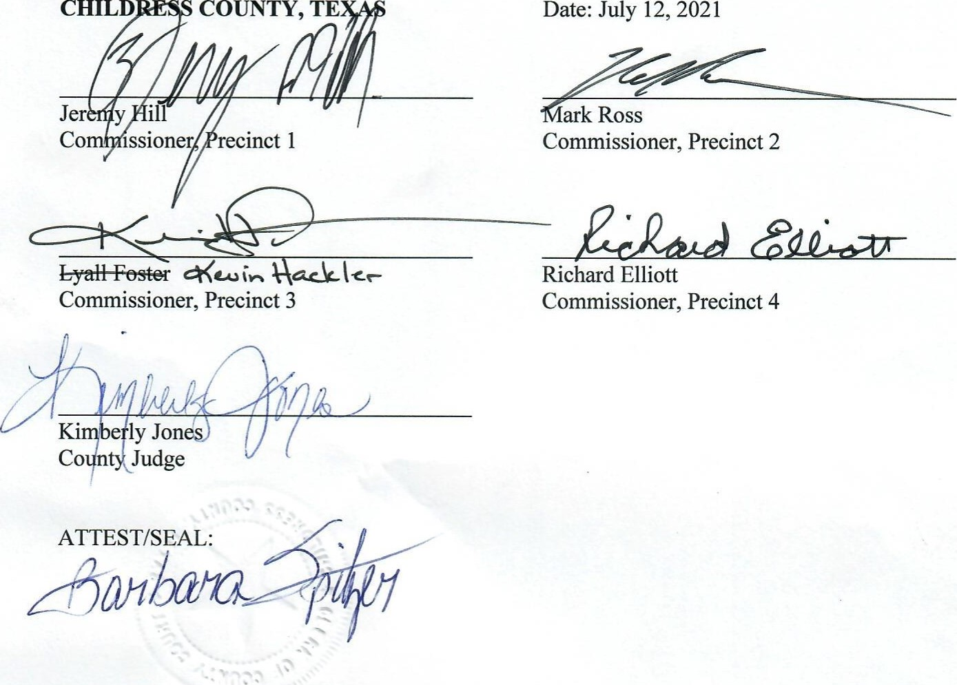

EXCEL ADVANTAGE SERVICES, LLC a Texas limited liability company

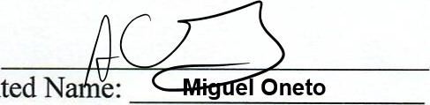By:

Date: 7/16/21

Printed N

Title: Manager

# Attachment A

Attached is the Reinvestment Zone created by resolution dated June 14, 2017, duly passed by the County Commissioners Court and referred to as the Reinvestment Zone 2017-01.

1. A document with text on it

   Description automatically generated reasonably likely as a result of the designation to contribute to the retention or A document with text on it

   Description automatically generated

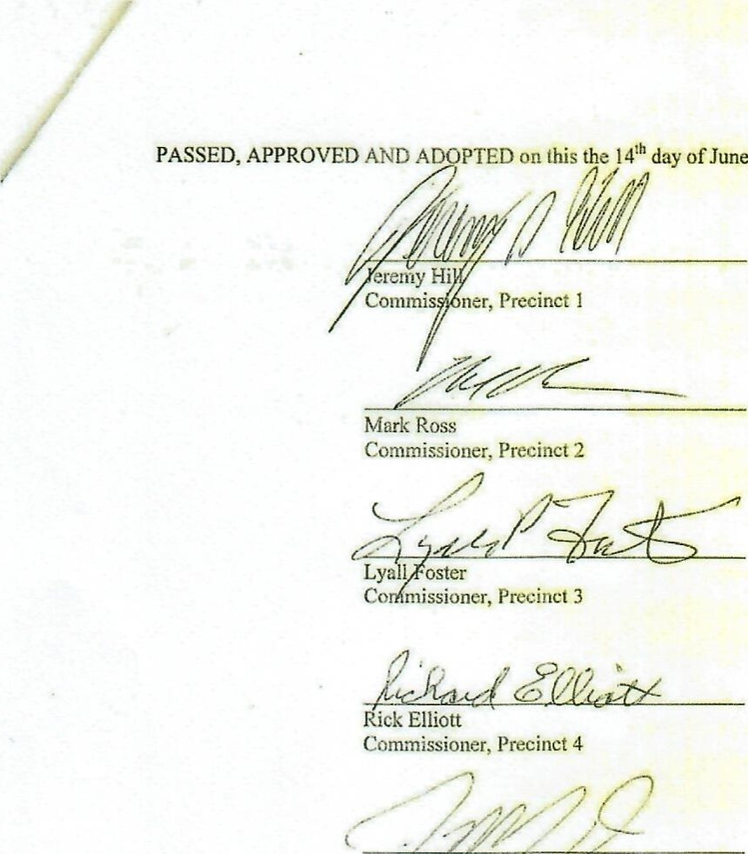

ofJune,

2017.

# EXHIBIT A

DESCRIPTION OF

REINVESTMENT ZONE 2017-01

Reinvestment Zone 2017-01 is comprised of the following parcel(s) located in Childress County Texas. Reinvestment Zone 2017-01 shall in no way be deemed to include any portion of any municipality.

All of those certain tracts of land generally described as lying west of the border between Childress County and Hardeman County, Texas; North of the border between Childress County and Cottle County, Texas; east of Childress County Road 1 5; and south of U.S. Highway 287.

Childress County Resolution —Reinvestment Zone 2017-01 Solo Page

Exhibit A

# EXHIBIT B

MAP OF

REINVESTMENT ZONE 2017-01

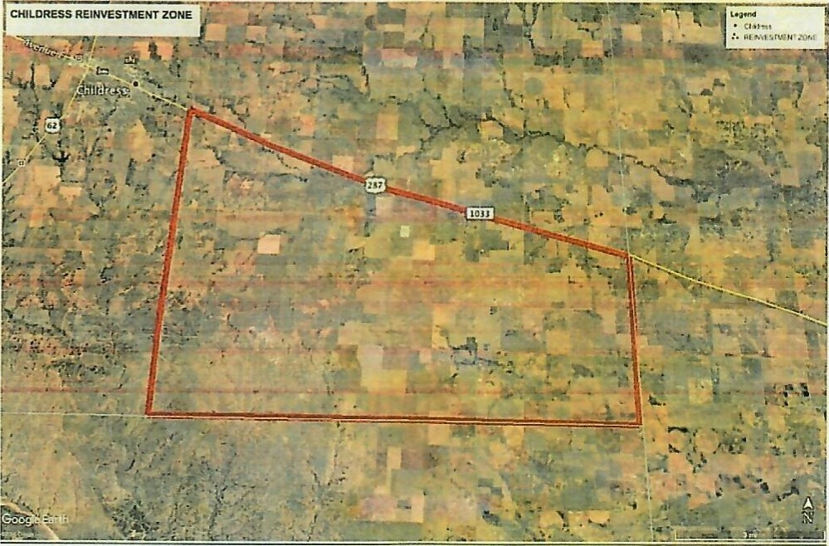

Childress County Resolution —Reinvestment Zone 2017-01 Solo Page

Exhibit B

## **Attachment B**

**LOCAL SPENDING AND SUPPORT PLAN**

1. In connection with the construction and operation of the Improvements in Childress County, Texas (the "Project"), Excel Advantage Services, LLC ("Owner") and the Owner's prime contractor(s) ("Prime Contractor(s)") responsible for overseeing construction and/or operation of the Improvements will use commercially reasonable efforts to use services, materials, and supplies purchased from Childress County individuals and businesses, provided that nothing in this paragraph shall require Owner or the Prime Contractor(s) to use services, materials and supplies provided by Childress County residents that are not: (i) of similar quality to those provided by nonresidents; or (ii) made available on terms and/or at prices comparable to those offered by nonresidents. Within ninety (90) days following completion of physical construction of the Project, Owner shall provide the County with a written project summary showing its compliance with the requirement set forth in this Local Spending and Support Plan.
2. In no event shall Owner or the Prime Contractor discriminate against Childress County residents in employment or in the purchase of goods and services.
3. In filling employment vacancies in connection with the Project, Owner and the Prime Contractor(s) will use commercially reasonable efforts to use Childress County labor, provided that nothing in this paragraph shall require Owner or the Prime Contractor to employ Childress County residents who are not: (i) equally or more qualified than nonresident applicants; or (ii) available for employment on terms and/or at salaries comparable to those required by nonresident applicants.
4. Owner or the Prime Contractor shall designate a Coordinator of Local Hiring and Services who will act as a liaison between all contractors and any individual or business residing in Childress County who is interested in obtaining information about (1) employment, or (2) commercial services or supplies expected to be purchased by a contractor.
5. Owner or the Prime Contractor shall hold a job and contracting information session prior to beginning physical construction of the Project at which information will be provided regarding the construction and hiring needs of the Project. Such information also will be provided on a continuing basis through the Coordinator of Local Hiring and Services.
6. For every year during the Term after the construction of the Improvements has been completed, Owner, its contractors and/or affiliates will collectively employ at least one (1) full time employee in Childress County.

Attachment B

Local Spending and Support Plan Solo

## **Attachment C**

Project Site

