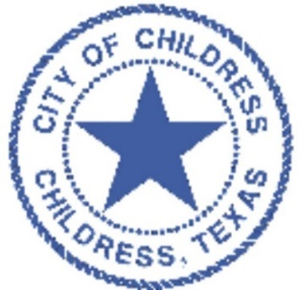

City of Childress
Public Safety Advisory
*UPDATE* Rabies Warning
The Childress Police Department and Animal Control Department have been notified by the Texas Department of State Health Services that the number of positive rabies infections in animals is now five (5) this season. Two foxes and one more skunk have tested positive for rabies in Childress County.
One factor that has been identified as a major contributor to the growth of the feral cat population in Childress is the food being left outside intentionally to feed the cats. Feral and domesticated cats are just as susceptible to rabies infection. Food placed out for cats also attracts skunks and other wildlife increasing the potential for rabies exposure. Please avoid placing food of any kind out for feral cats and other animals.
The City of Childress wants to increase awareness and caution when observing or spotting a free roaming animal such as a skunk, fox, racoon, bats, or coyote. This also includes feral cats. These animals may be infected with rabies. Please exercise the upmost caution if you see one of these animals and observe these simple practices:
- Never approach or get too close to a wild animal.
- If you accidentally find yourself near a wild animal, quickly move to a safer location.
- Never attempt to touch or handle a skunk, fox, racoon, coyote, bats or feral cats no matter if it is young or injured.
- If a wild animal such as a skunk, fox, racoon, coyote, bats or feral cat needs to be removed from a property, contact animal control or local law enforcement (940)937-2535.
- If you are bitten or scratched by a wild animal, immediately wash the wound thoroughly and contact a health care provider or emergency medical personnel.
- Any wild animal that bites a human should be captured or destroyed if safe to do so without damaging the head. The head is necessary for testing.
- Contact Animal control for assistance and collection immediately.
- Closely watch your pets for signs of infection such as behavior change, aggressiveness, in-coordination, or excessive salivation. If that happens contact a veterinarian for assessment.

