Childress Vaccine Email/Fax Request

This serves as a vaccine request for you to receive the COVID-19 vaccine in the Panhandle Plains region of Texas, Public Health Region 1. This is available in all public health counties without a local health department of their own. No need to come to us, we are happy to come to you.

After sending this request, a representative with the Texas Department of Public Health will reach out to you to make an appointment for you to receive your vaccination. We are happy to come directly to your home or work to provide this vaccine at no cost to you.

Name Your Name here

Address Your Address here

Phone Number Your phone number

Type of Vaccine Requested? (Moderna, Pfizer, Johnson)Choose an item.

Address where you would like to receive the vaccination? Location

What potential days can you be available at this location to receive the vaccination?
List the days and times you are available

Thank you for making this effort to be vaccinated!

Please return this request to me by e-mail or fax and a member of our team will contact you to set up an appointment to be vaccinated.

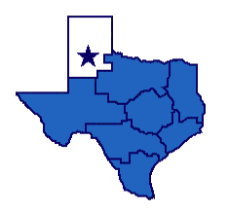
Sam Reedy
Preparedness and Response
Texas Department of State Health Services
Public Health Region 1
6302 Iola Ave
Lubbock, TX 79424

Office: 806-783-6476
Fax: 806-783-6466
Samuel.Reedy@dshs.texas.gov

